Transformations with Quadratic Functions

Objectives: Write the quadratic function in the form $y=a(x-h)^{2}+k.$ Transform graphs of quadratic functions of the form $y=a(x-h)^{2}+k.$

Vocabulary- vertex form, $y=a(x-h)^{2}+k$
(h,k) is the vertex of the parabola, x=h is the axis of symmetry, and a determines the shape of the parabola and the direction in which it opens.

Day 1
Objectives: Write the quadratic function in the form $y=a(x-h)^{2}+k.$

Example 1
Complete the square to write quadratic function in vertex form.

- $y=x^{2}+6x-5$

- $y=-2x^{2}+8x-3$

Students will use desmos.com or desmos app on ipad to check answers.
Graph equation in first line. Graph answer in second line. If second parabola traces first parabola, then your answer is correct. If graph does not trace, enter in all lines to see were the mistake was made. First graph that doesn’t trace is were mistake is made.

Example 2
Given the vertex and a point on the parabola. Write the equation for the parabola in vertex form.
- vertex (3,2) point (-1,-2)

- vertex (-1,-2) point (-4, 13)

Students will use desmos.com or desmos app on ipad to check answers.
Graph parabola in vertex form in line 1. Click or tap on vertex to see if matches original problem. Enter point in line 2 (x-coordinate, y-coordinate) to see if point is on parabola.

Online tutorials for absent students or students who need to see more examples
Example 1
http://www.glencoe.com/sites/common_assets/mathematics/alg2_2010/pt/A2_5-7-1/A2_5-7-1.html
https://www.khanacademy.org/math/algebra/quadratics/completing_the_square/v/ex3-completing-the-square
Example 2
http://www.glencoe.com/sites/common_assets/mathematics/alg2_2010/pt/A2_5-7-2.swf

Day 2
Objectives: Transform graphs of quadratic functions of the form
$y=a(x-h)^{2}+k.$

Generating and Testing Hypotheses
Students will each have their own ipad, but will work in groups of two.
- Teacher will ask a specific question on tranformations.
- Students will discuss in groups and write down their hypotheses.
- Students will test their hypotheses using the desmos app.
- Explain the results of their experiment and make any changes to their original hypotheses.

Desmos app or desmos.com for students who were not in class.
Line 1. Enter $y=a(x-h)^{2}+k$, add all sliders
Line 2. a=1
Line 3. Change h=0
Line 4. Change k=0
Line 5. Enter (h,k)
Now we are ready to rock and roll.

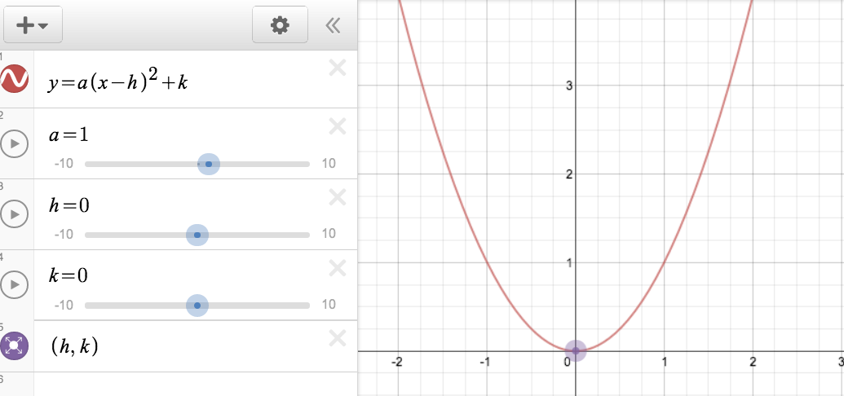

Describe the transformation. Test by using the sliding feature in desmos.
- $k>0$ (k is positive)

- $k<0$ (k is negative)

- $h>0$ (h is positive)

- $h<0$ (h is negative)

- $a>0$ (a is positive)

- $a<0$(a is negative)

- $0<a<1$

- $a>1$

Find vertex. List transformations in correct order.
Example $y=-2(x-3)^{2}-5$
Vertex (3,-5)
Transfromations- right 3 units, reflection across x-axis, vertically stretch by 2, down 5 units

- $y=(x-2)^{2}$

10. $y=x^{2}+7$

- $y=(x+4)^{2}-5$

12 $y=-(x+3)^{2}$

13. $y=\frac{1}{2}(x-4)^{2}+6$

14. $y=2(x+7)^{2}-3$

15. $y=-3(x-5)^{2}+4$

16. $y=x^{2}+4x-6$

17. $y=-2x^{2}+6x+10$

Challenge $y=(x+a)^{2}+b$
Vertex ( , )

For those who really want to be challenged.
A ball is launched straight up from ground level with an initial velocity of 288 ft/sec.
Height (h) of the ball as a function of time (t) is given by the equation
$h\left(t\right)=-16t^{2}+288t.$
What is the maximum height obtained by the ball and at what time?

$$f\left(x\right)=a(x-h)^{2}+k$$

h, Horizontal Translation
h units to the right if h is positive, $\left|h\right|$ units to the left if h is negative
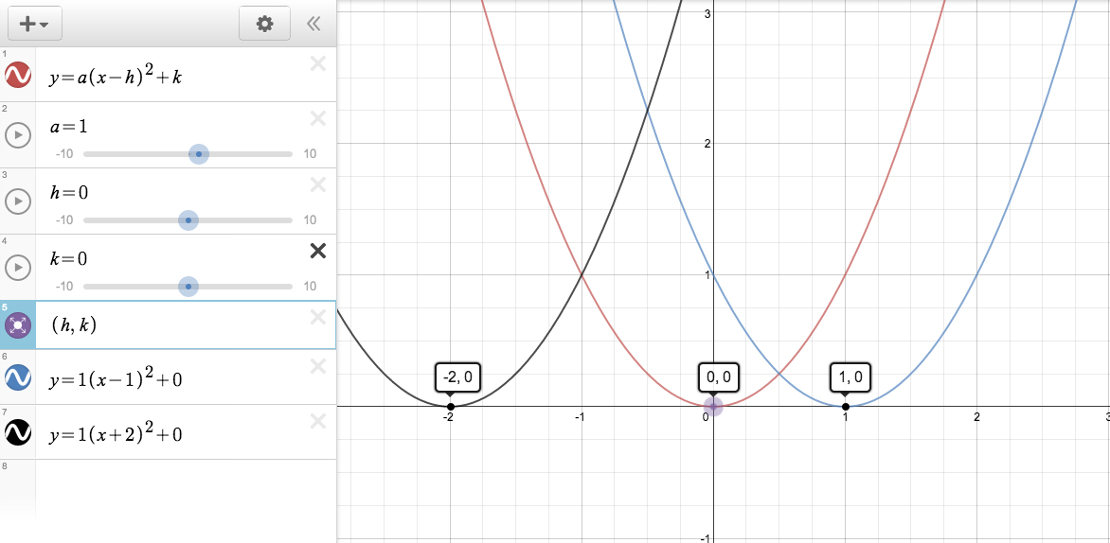

$$f\left(x\right)=a(x-h)^{2}+k$$
k, Vertical Translation
k units up if k is positive, $\left|k\right|$ units down if k is negative

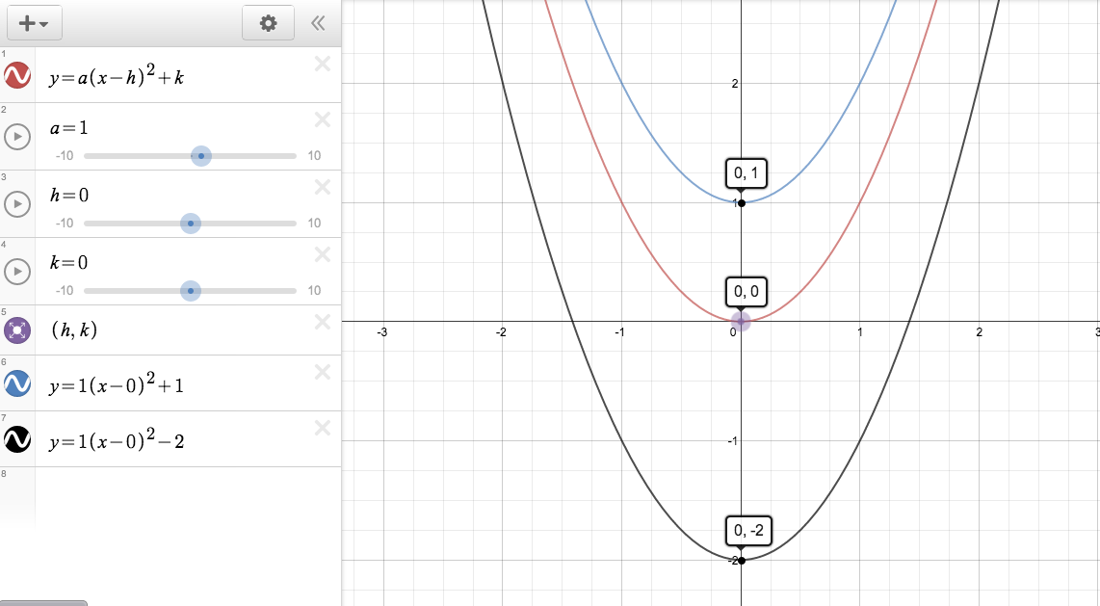

$$f\left(x\right)=a(x-h)^{2}+k$$

a, Reflection
If $a>0,$ the graph opens up. If $a<0,$ the graph opens down (reflection across x-axis)

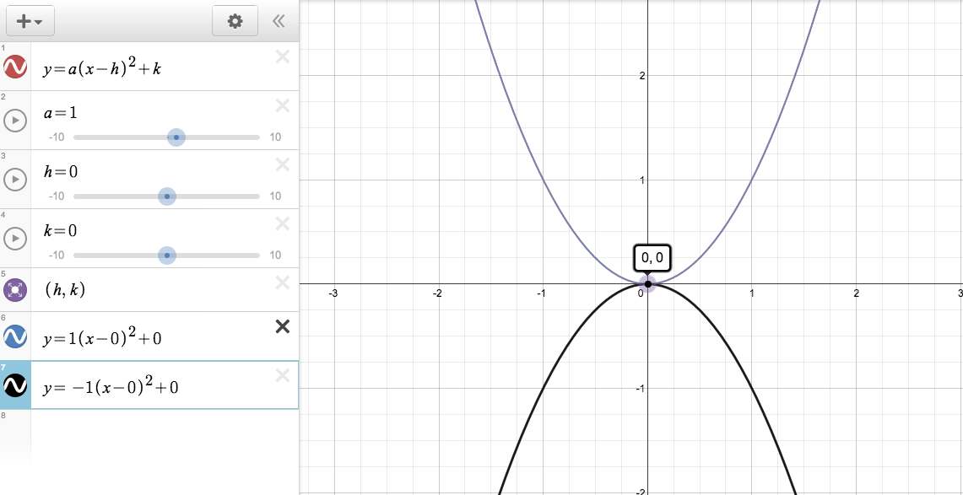

$$f\left(x\right)=a(x-h)^{2}+k$$

a, Dilation
If $\left|a\right|>1,$ the graph is stretched vertically. If $0<\left|a\right|<1,$ the graph is compressed vertically.

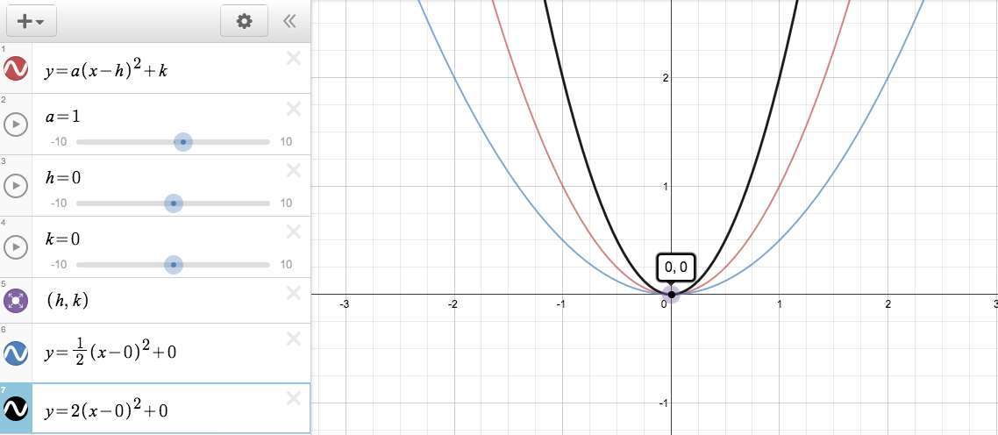

Online tutorials for absent students or students who need to see more examples
http://www.glencoe.com/sites/common_assets/mathematics/alg2_2010/pt/A2_5-7-3.swf

